FIT3003 Business Intelligence and Data Warehousing
Sample Exam Paper 1 [SOLUTION]

Question 1
Monash International would like to analyse their policy in regard to English requirements for admission into a course. Monash International has the following data:
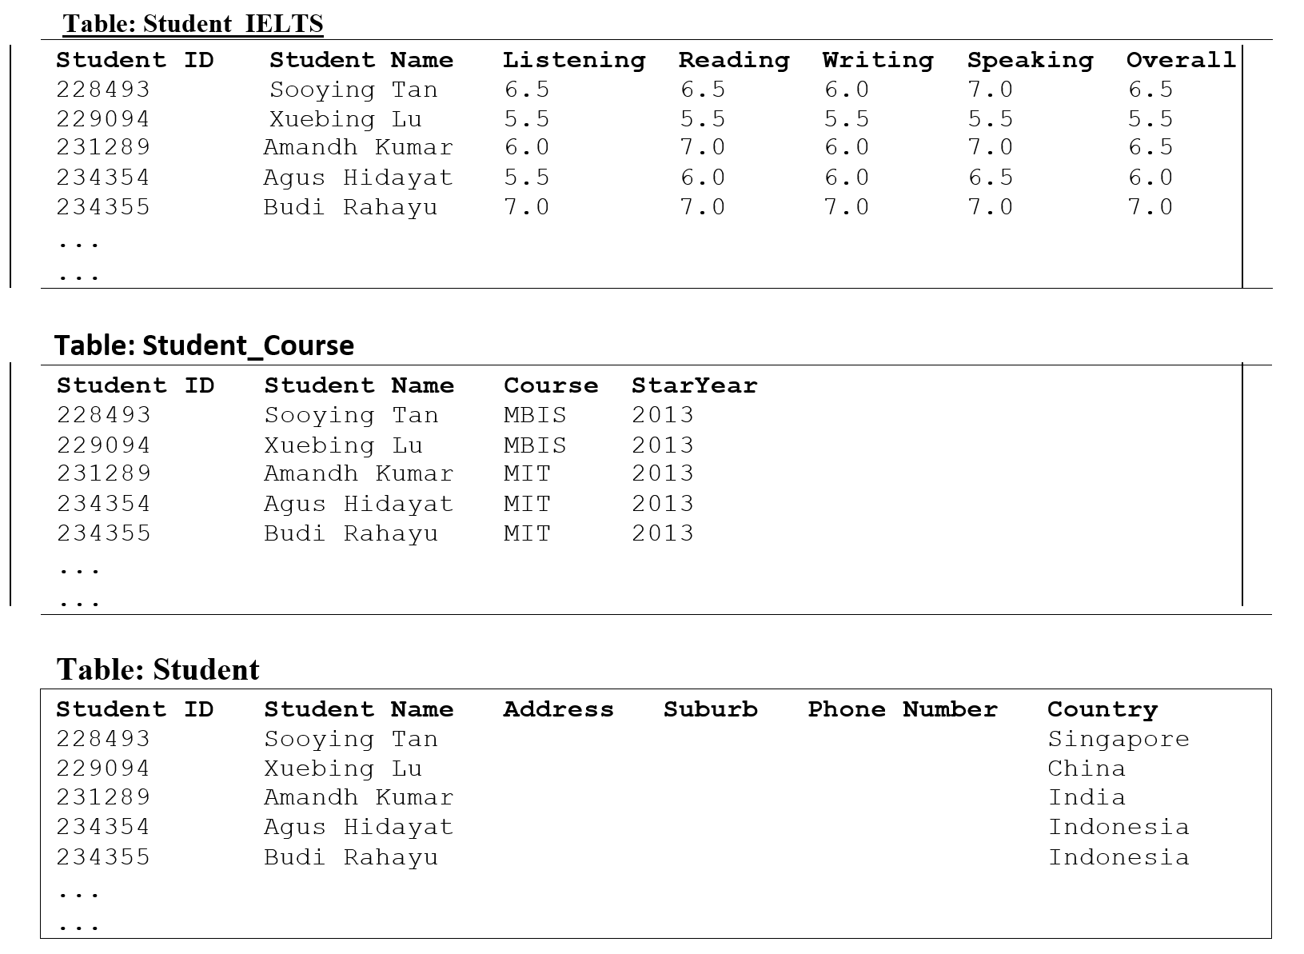A data warehouse based on the above data has been created. A star schema is shown as follows:
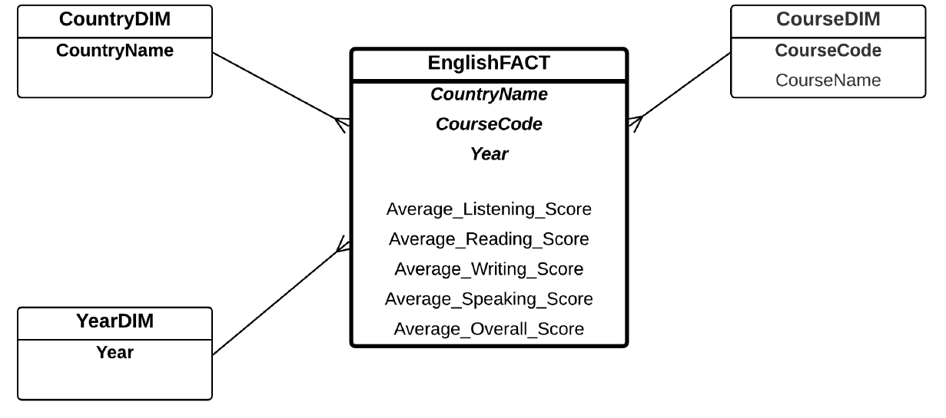 Questions:
- The above star schema will not produce a correct analysis of the fact measures. Explain why. Explain your answer using more concrete examples or data. (5 marks)
- How do you correct this problem by changing the fact measures of the above star schema? Explain your solution using more concrete examples or data. (5 marks)
Solution:
a) If the operational database contains 10 students from Indonesia doing MIT in 2013, the fact table will contain only one entry, which aggregates these 10 students. The fact will aggregate the IELTS scores (i.e. listening, reading, writing, speaking, and overall score) and get the average (e.g. average listening, average reading, average writing, average speaking, and average overall score). This will be done for each combination of country, course, and year.
However, if in the OLAP, we would like to get the average scores of students from a specific country, say Indonesia, then we will need to get all the records where the country is Indonesia from the fact table. And then average it again.
The records in the fact table are already averaged. If we average on top of another average, the result will be incorrect.
For example, the fact table of the above sample data is shown as follows:
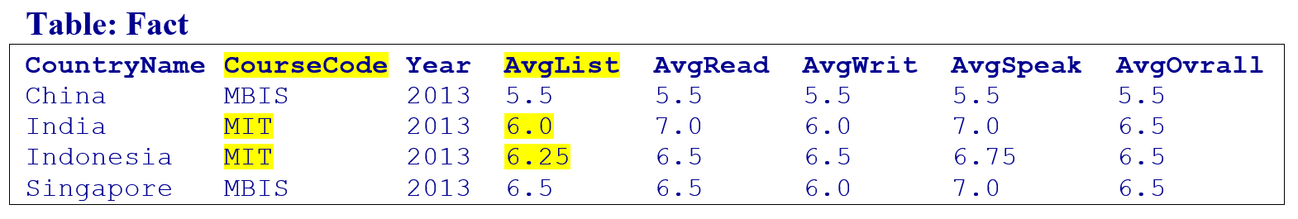
If we query the Average Listening Score of MIT students, then based on the above fact table, the average listening score is (6.0+6.25)/2 = 6.125.
Supposed in the operational database, there are three students from India and Indonesia (e.g. Amandh from India, and Agus and Budi from Indonesia):
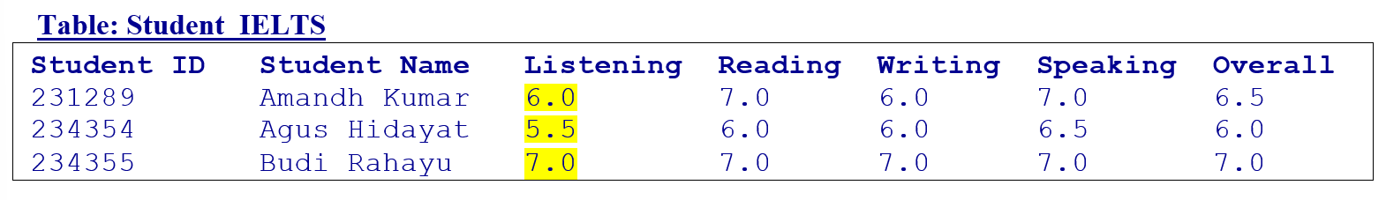
If we look at these three students from India and Indonesia (Amand, Agus, and Budi), the average listening score is (6.0+5.5+7.0)/3 = 6.17.
This example shows that keeping the average score in the fact will produce incorrect OLAP query results. Hence, average is not a good fact measures. We should not have average_reading, average_listening, etc in the fact.
b) We should have total_reading, total_listening, total_speaking, total_writing, and total_overall in the fact. We also need total_number_of_students in the fact.
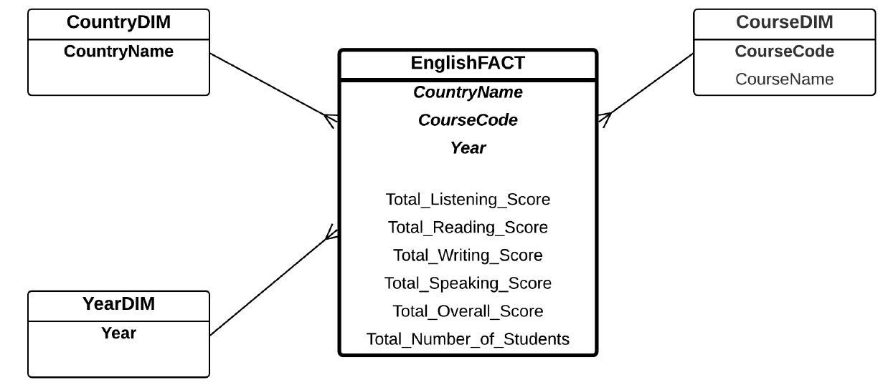
So, in OLAP, if we want to get the Average Listening Score of MIT course students, we will get the total_listening and total_number_of_students, and then divide them to get the average. Using the example above, total_listening = (6.0+5.5+7.0) = 18.5, and total_number_of_students = 3. Then listening average is 18.5/3 = 6.17

Question 2
The MonMusic is a mobile app that allows its users to download songs. When an individual joins MonMusic as a new user, they are given a unique user id and their details (such as name, email, phone number, and country) are recorded. After joining, members can start downloading songs and MonMusic records the date and time of when the member downloads the song. The download fee is also recorded to the system depending on the song the user chose.
Each song in MonMusic has a unique song id. The genre (e.g. Pop, Classic, Rock, etc.) and the details of the artists of each song are also recorded in the system. Each song may involve several artists and an artist can appear in several songs.
Finally, the MonMusic users can provide some reviews of the songs. Each review contains the song id, user id, review date, content, and the rating (within 5 stars).
The E/R diagram of the operational database is shown as follows:
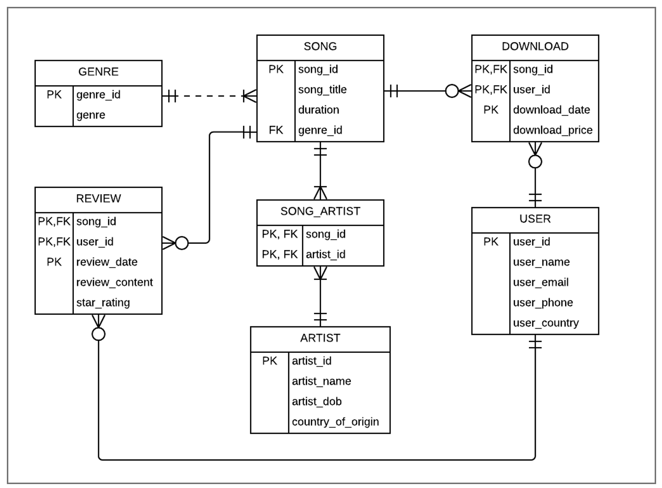
MonMusic requires a data warehouse for analysis of the number of downloaded songs and the total download revenue. Particularly, data analysis is needed for answering the following questions:
- How much is the total download revenue in Summer?
- How many songs are downloaded by users located in Australia?
- How much is the total download revenue for each artist?
- How much is the total download revenue for Classic songs during Winter 2020?
Questions:
a. Based on the above requirements, develop a star/snowflake schema. If you are using a Bridge Table, make sure to include a Weight Factor attribute and a ListAGG attribute. (15 marks)
b. Write the queries to create (and populate) the dimension tables, and the fact table. You do not need to write the SQL to answer the requirement questions above. (15 marks)
Solution:
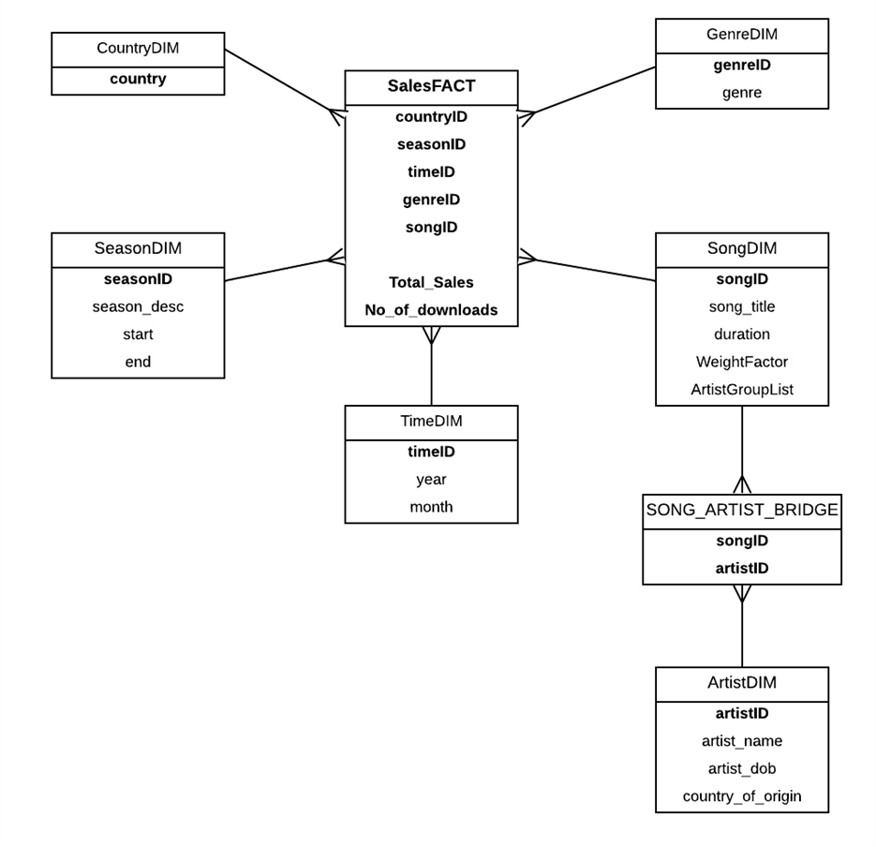
CREATE TABLE TIMEDIM AS SELECT DISTINCT
TO_CHAR(DOWNLOAD_DATE, ‘YYYYMM’) AS TIMEID,
TO_CHAR(DOWNLOAD_DATE, ‘MM’) AS MONTH,
TO_CHAR(DOWNLOAD_DATE, ‘YYYY’) AS YEAR FROM DOWNLOAD;

CREATE TABLE COUNTRYDIM AS SELECT * FROM USER;
CREATE TABLE GENREDIM AS SELECT * FROM GENRE;
CREATE TABLE SEASONDIM (SEASONID NUMBER, S_DESC VARCHAR2(15), S_START VARCHAR2(15), S_END VARCHAR2(15));

INSERT INTO SEASONDIM VALUES (1, 'SPRING', 'SEPTEMBER', 'NOVEMBER');
INSERT INTO SEASONDIM VALUES (2, 'SUMMER', 'DECEMBER', 'FEBRUARY');
INSERT INTO SEASONDIM VALUES (3, 'AUTUMN', 'MARCH', 'MAY');
INSERT INTO SEASONDIM VALUES (4, 'WINTER', 'JUNE', 'AUGUST');

CREATE TABLE SONGDIM AS SELECT M.SONG_ID, M.SONG_TITLE, M.DURATION,
1.0/COUNT(*) AS WEIGHTFACTOR, LISTAGG (A.ARTIST_ID, ‘_’) WITHIN GROUP (ORDER BY A.ARTIST_ID) AS ARTISTGROUPLIST
FROM SONG M, SONG_ARTIST A WHERE M.SONG_ID = A.SONG_ID
GROUP BY M.SONG_ID, M.SONG_TITLE, M.DURATION;

CREATE TABLE ARTISTDIM AS SELECT * FROM ARTIST;
CREATE TABLE BRIDGETABLE AS SELECT * FROM SONG_ARTIST;

CREATE TABLE MUSICTEMP AS SELECT U.USER_COUNTRY AS COUNTRY_ID, D.DOWNLOAD_DATE, M.GENRE_ID, M.SONG_ID, D.DOWNLOAD_PRICE, TO_CHAR(D.DOWNLOAD_DATE, ‘YYYYMM’) AS TIMEID
FROM USER U, DOWNLOAD D, SONG M
WHERE M.SONG_ID = D.SONG_ID AND D.USER_ID = U.USER_ID;

ALTER TABLE MUSICTEMP ADD(SEASONID NUMBER);

UPDATE MUSICTEMP SET SEASONID = 1 WHERE TO_CHAR(DOWNLOAD_DATE, 'MM')>= '09' AND TO_CHAR(DOWNLOAD_DATE, 'MM') <='11';
UPDATE MUSICTEMP SET SEASONID = 2 WHERE TO_CHAR(DOWNLOAD_DATE, 'MM')>= '12' OR TO_CHAR(DOWNLOAD_DATE, 'MM') <='02';
UPDATE MUSICTEMP SET SEASONID = 3 WHERE TO_CHAR(DOWNLOAD_DATE, 'MM')>= '03' AND TO_CHAR(DOWNLOAD_DATE, 'MM') <='05';
UPDATE MUSICTEMP SET SEASONID = 4 WHERE TO_CHAR(DOWNLOAD_DATE, 'MM')>= '06' AND TO_CHAR(DOWNLOAD_DATE, 'MM') <='08';

CREATE TABLE MUSICFACT AS SELECT COUNTRY_ID, SEASONID, TIMEID, GENRE_ID, SONG_ID, SUM(DOWNLOAD_PRICE) AS TOTAL_SALES, COUNT(SONG_ID) AS NO_OF_DOWNLOAD FROM MUSICTEMP GROUP BY COUNTRY_ID, SEASONID, TIMEID, GENRE_ID, SONG_ID;

Question 3
In the Determinant Version of the PTE Academic Test case study, the fact table is shown below containing 45 records. For example, if a combination of all dimension keys does not have any students, in this example, it will not show as a zero – it will simply be excluded in the fact table.
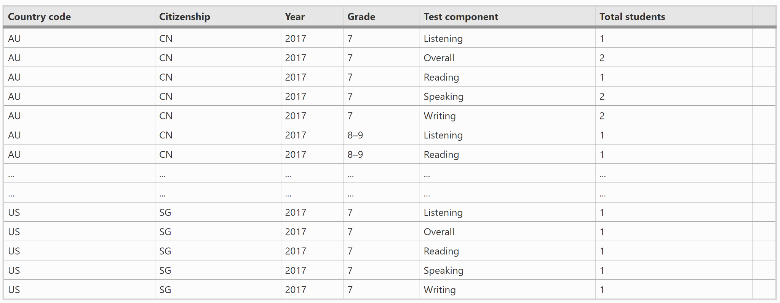
Question: If we want to also show zeroes in the Total Students column (for those combinations of all Dimensions’ key that do not have any students), what is the SQL command to produce this? How many records will there be in this new fact table?
Solution:
CREATE TABLE ALLDIMENSIONS AS SELECT CO.COUNTRYCODE, CI.CITIZENSHIP, Y.YEAR, G.GRADE, T.TESTCOMPONENT
FROM COUNTRYVENUEDIM CO, CITIZENSHIPDIM CI, YEARDIM Y, GRADEDIM G, TESTCOMPONENTDIM T;
--This will produce 300 records
--2 country venues, 6 citizenships, 1 year, 5 grades, 5 test components
--Total combinations = 300 records
--Then do an outer join between AllDimensions and
--the FinalFact
CREATE TABLE FINALFACTNEW AS SELECT
A.COUNTRYCODE, A.CITIZENSHIP, A.YEAR, A.GRADE, A.TESTCOMPONENT,
NVL(F.TOTAL_STUDENTS, 0) AS TOTAL_STUDENTS
FROM ALLDIMENSIONS A, FINALFACT F
WHERE A.COUNTRYCODE = F.COUNTRYCODE(+) AND A.CITIZENSHIP = F.CITIZENSHIP(+)
AND A.YEAR = F.YEAR(+) AND A.GRADE = F.GRADE(+) AND A.TESTCOMPONENT = F.TESTCOMPONENT(+);

Question 4
A bookshop offers two kinds of sales: in-shop sales and online sales. Each of these maintains its own database system. The In-Shop Sales E/R diagram is shown below. In this database, the details of the books are stored in various tables, namely Book, Author, Title Author, Publisher and Category. Information on the sales are stored in tables: Sales and Sales Details. Because this information relates to In-Shop Sales, the Employee who performed the sales is recorded. The Employee is also attached to a particular Branch, and of course, each sale is performed in a branch. Note that this kind of circular relationship of entities does not follow the Boyce-Codd Normal Form (BCNF).
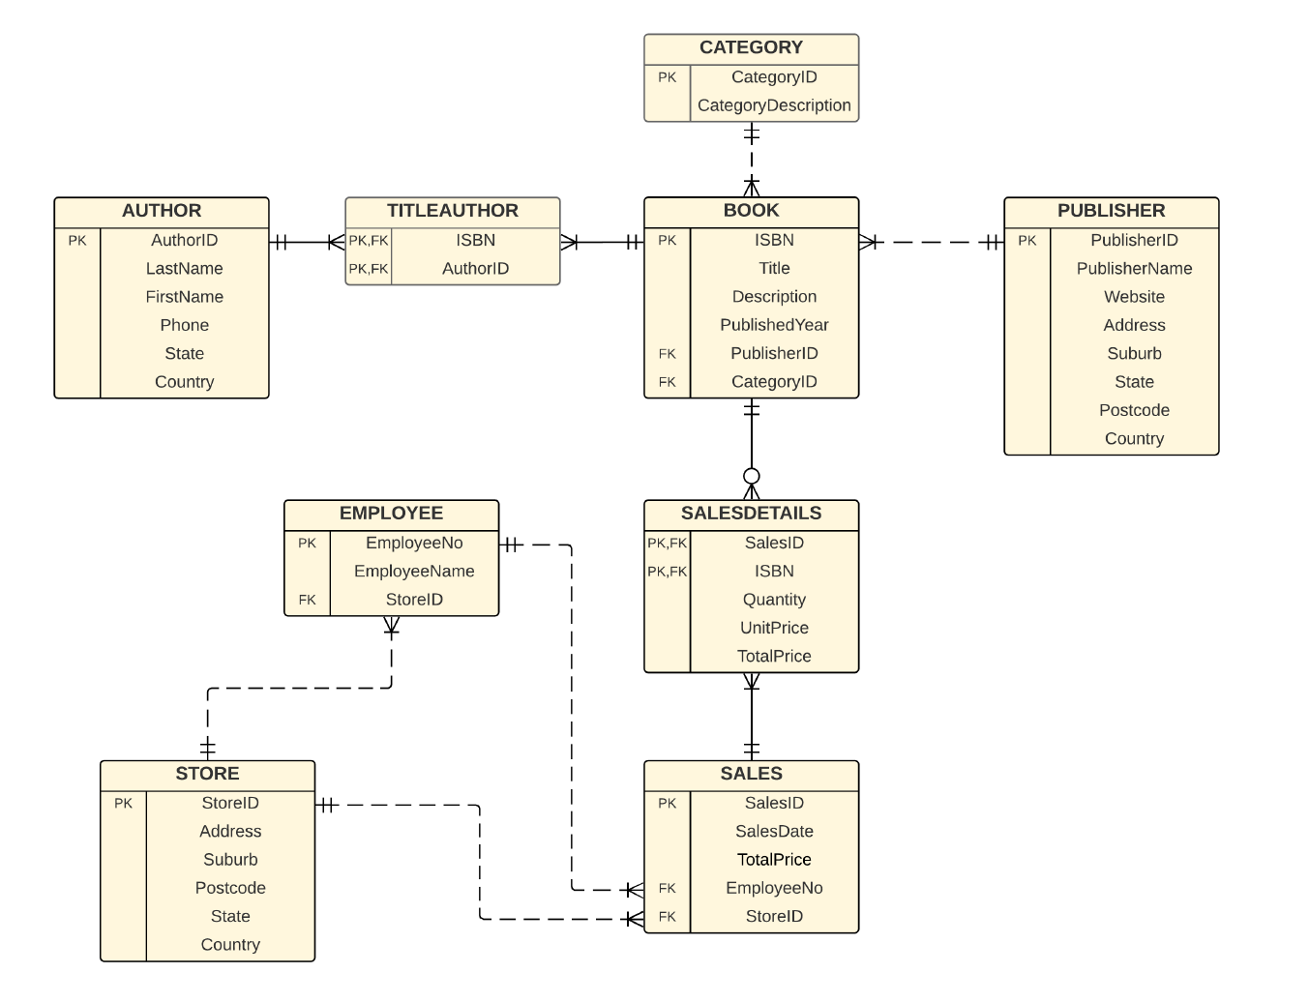
The Online Sales E/R diagram is shown below
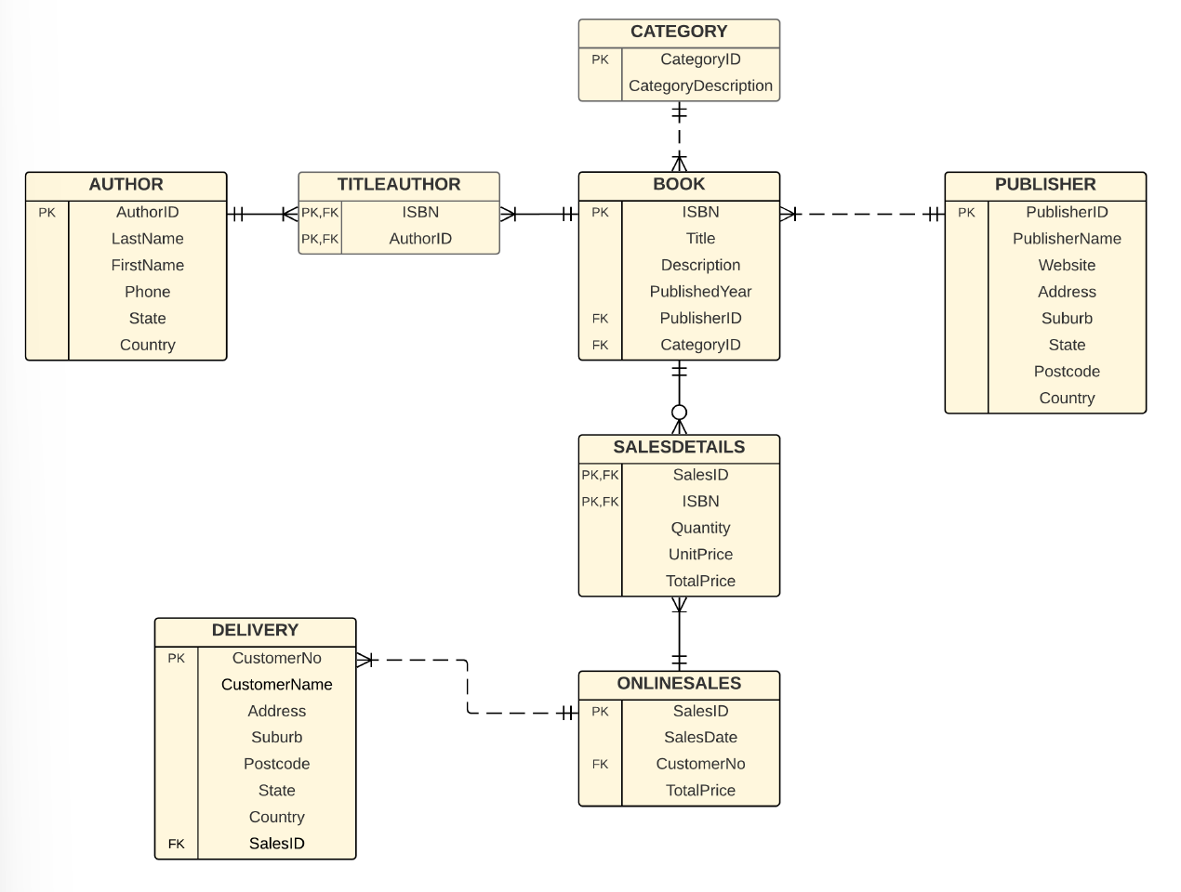
The details on the books are the same as those in the In-Shop Sales E/R diagram, namely Book, Author, Title Author, Publisher and Category. However, the Sales are simpler. It has only two entities: Online Sales and Sales Details. However, it has one additional entity, Delivery, which records the delivery address. Information about the Employee who performed the sale is not recorded.
An integrated star schema is requested by this bookshop. The star schema will take both In-Store Sales and Online Sales databases. The star schema needs to include Total Books Sold and Total Price. The star schema is shown below:
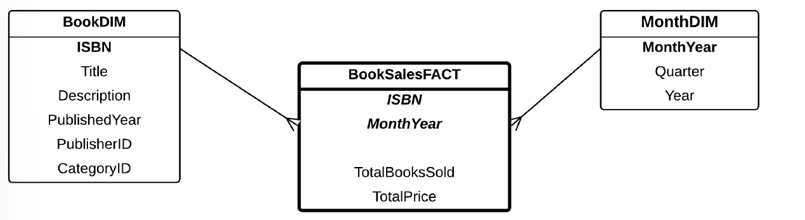
Your task is to implement this star schema using the SQL commands.

Solution:
CREATE TABLE TEMPMONTHDIM AS ( SELECT DISTINCT TO_CHAR (SALESDATE, 'MMYYYY') AS MONTHYEAR, TO_CHAR(SALESDATE, 'MON') AS MONTH, TO_CHAR(SALESDATE, 'YYYY') AS YEAR FROM "INSHOP SALES"
UNION
SELECT DISTINCT TO_CHAR (SALESDATE, 'MMYYYY') AS MONTHYEAR, TO_CHAR(SALESDATE, 'MON') AS MONTH, TO_CHAR(SALESDATE, 'YYYY') AS YEAR FROM "ONLINE SALES");

ALTER TABLE TEMPMONTHDIM ADD QUARTER VARCHAR2(20);

UPDATE TEMPMONTHDIM SET QUARTER = 'SPRING' WHERE MONTH >= '09' AND MONTH <'12';
UPDATE TEMPMONTHDIM SET QUARTER = 'SUMMER' WHERE MONTH >= '12' OR MONTH <'03';
UPDATE TEMPMONTHDIM SET QUARTER = 'AUTUMN' WHERE MONTH >= '03' AND MONTH <'06';
UPDATE TEMPMONTHDIM SET QUARTER = 'WINTER' WHERE MONTH >= '06' AND MONTH <'09';

CREATE TABLE MONTHDIM AS SELECT MONTHYEAR, QUARTER, YEAR FROM TEMPMONTHDIM;
CREATE TABLE BOOKDIM AS SELECT * FROM BOOK;

CREATE TABLE TEMPBOOKSALESFACT1 AS SELECT ISBN, TO_CHAR (SALESDATE, 'MMYYYY') AS MONTHYEAR, SUM(QUANTITY) AS TOTALBOOKSSOLD, SUM(S.TOTALPRICE) AS TOTALPRICE
FROM SALESDETAILS S, "INSHOP SALES" I
WHERE S.SALESID = I.SALESID GROUP BY ISBN, TO_CHAR (SALESDATE, 'MMYYYY');

CREATE TABLE TEMPBOOKSALESFACT2 AS SELECT ISBN, TO_CHAR (SALESDATE, 'MMYYYY') AS MONTHYEAR, SUM(QUANTITY) AS TOTALBOOKSSOLD, SUM(O.TOTALPRICE) AS TOTALPRICE
FROM SALESDETAILS S, "ONLINE SALES" O
WHERE S.SALESID = O.SALESID GROUP BY ISBN, TO_CHAR (SALESDATE, 'MMYYYY');

CREATE TABLE BOOKSALESFACT AS SELECT ISBN, MONTHYEAR,
SUM(TOTALBOOKSSOLD) AS TOTALBOOKSSOLD, SUM(TOTALPRICE) AS TOTALPRICE FROM
( SELECT ISBN,MONTHYEAR, TOTALBOOKSSOLD, TOTALPRICE FROM TEMPBOOKSALESFACT1
UNION
SELECT ISBN, MONTHYEAR, TOTALBOOKSSOLD, TOTALPRICE FROM TEMPBOOKSALESFACT2)
GROUP BY ISBN, MONTHYEAR;

Question 5
The E/R diagram for MonMusic operational database is as below:
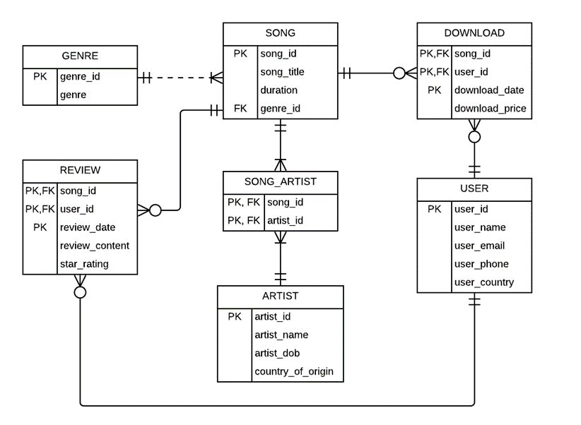
The operational database may need some data exploration and data cleaning, as we are not sure if the constraints (e.g. PK, FK) have all been correctly implemented, and whether the data is free from errors.
Questions: Write the SQL command to do the following data exploration:
a. What is the SQL command to find out if there are duplicate users? Provide a data cleaning solution for this issue. (3 marks)
b. What is the SQL command to check if there are songs that do not belong to any genre? (2 marks)
c. What is the SQL command to check if there are any downloads which have a download price of NULL? (2 marks)
d. Write the SQL command to find out if there are any illegal records in the review table (e.g. a record in review table that are actually not exist in other tables). (3 marks)

Solution:
(a)
SELECT USER_ID, COUNT(*) FROM USER GROUP BY USER_ID HAVING COUNT(*) > 1;
CREATE TABLE USER2 AS SELECT DISTINCT * FROM USER;
(b)
SELECT S.SONG_ID FROM SONG S WHERE S.GENRE_ID NOT IN (SELECT G.GENRE_ID FROM GENRE G);
(c)
SELECT * FROM DOWNLOAD WHERE DOWNLOAD_PRICE IS NULL;
(d)
SELECT * FROM REVIEW R WHERE R.SONG_ID NOT IN (SELECT S.SONG_ID FROM SONG S);
SELECT * FROM REVIEW R WHERE R.USER_ID NOT IN (SELECT U.USER_ID FROM USER U);
Question 6
A simple enrolment system E/R diagram is shown below. It consists of four tables. Table Student contains the details of students, whereas Table Subject contains the details of subjects or units. Table Offering is the actual instance of a subject showing when the subject is offered. Lastly, Table Enrolment contains the enrolment details of the students enrolling in an offering.
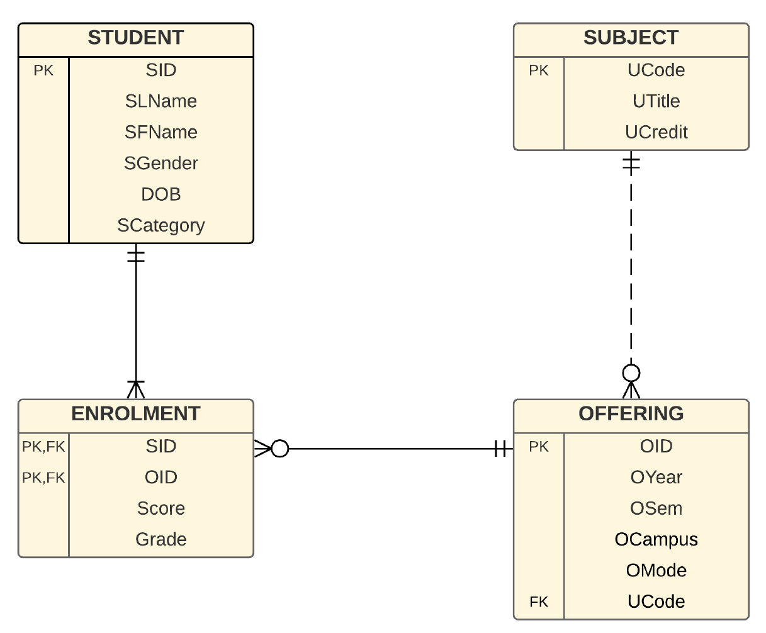
The University administrator needs to keep track of the number of enrolments for a particular unit or campus and the students’ performance each year in order to maintain the University’s performance.
The grading system used in this case study is HD for High Distinction, D for Distinction, C for Credit, P for Pass and N for Fail. This is equivalent to A, B, C, D and F used in many other grading systems. The star schema then has five fact measures: Number of HDs, Ds, Cs, Ps and Ns. The dimensions are Campus, Semester Year, Grade and Subject.
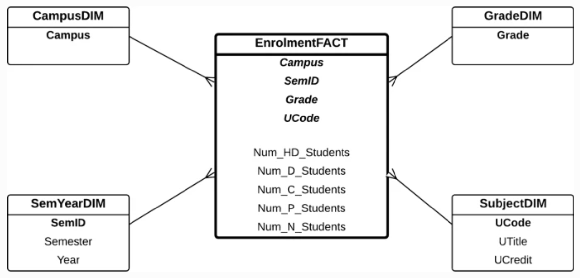
Question: Is this star schema correct? Why or why not?
Solution:
This star schema is Incorrect!!. The Grade Table has only five records, which are the five grades (e.g. HD, D, C, P, and N). Each record in the Fact Table contains four attributes from the key identifier of each dimension (e.g. Campus, SemID, Grade, and UCode), and the five attributes of the fact measures (e.g. Number of Students who got HD, D, C, P, and N). So, one record in the Fact Table contains all the nine attributes. So for example, if the first record in the Fact Table related to Main Campus, semester 1/2020, UCode ’IT001’, and a HD Grade, the Number of HD attribute in the fact will reflect number of students who got HD in that particular campus, on that particular semester, and for that particular subject. But that record in the Fact Table has other columns, which are Number of students who got the other grades. The values would all be zeros.
The same applies for other records in the Fact Table for other grades. Only the mentioned grade will have a value which reflects the number of students who obtained that particular grade, but will have zeroes for other grades. The correct star schema does not need the Grade Dimension
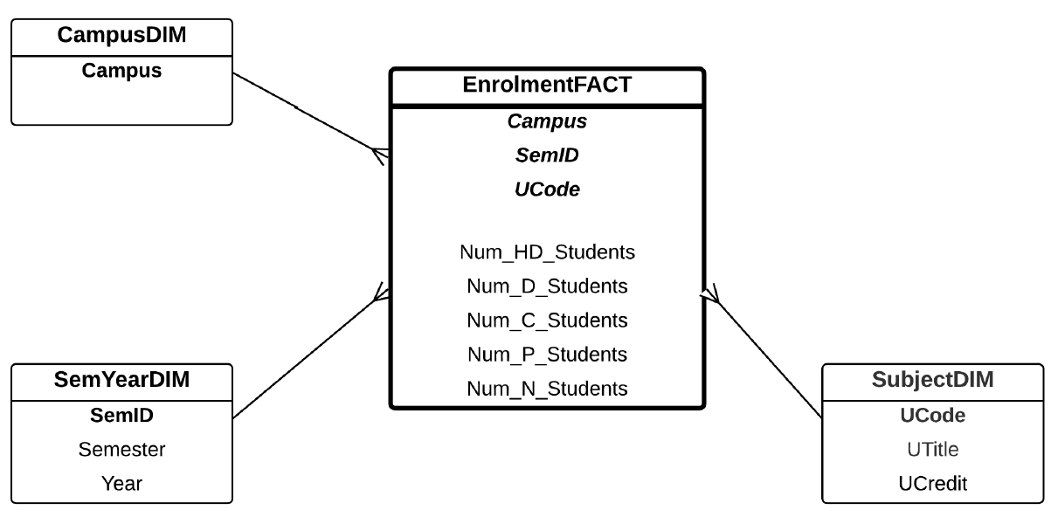
Question 7
Use the following case study when you answer the questions below:
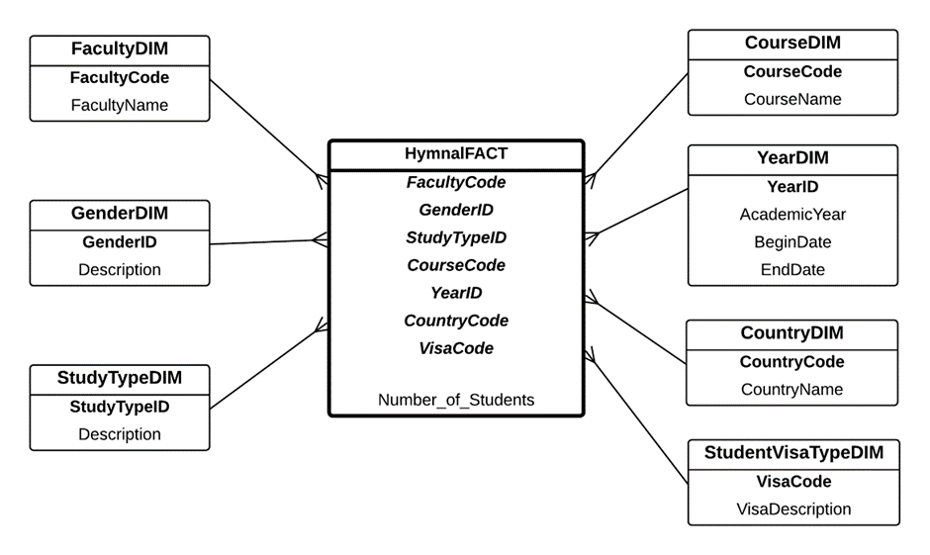
Notes:
- Study type is either Full Time or Part Time
- Student visa type is either International student or Domestic student
Questions:
- What is a Junk Dimension? State your answer. Use an example to illustrate your answer (2 marks)
- What is Star Join (also use an SQL to illustrate your point)? What is Cartesian Product in Star Join? When is Cartesian Product is used in Star Join? (4 marks)
- What is the similarity between Junk Dimension and Cartesian Product? What is the difference between Junk Dimension and Cartesian Product? (4 marks)
Solution:
(a) A Junk Dimension is a combined dimension from a smaller cardinality dimensions.
For example, instead of having three dimensions: GenderDIM, StudyTypeDIM, and StudentVisaTypeDIM, we can combine them and have a Junk Dimension instead.
(b)
Star Join is a join query involving a Fact table and it’s dimension tables. Because the link between the tables always involve the Fact (that is Fact-Dim1, Fact-Dim2, Fact-Dim3, etc), the join looks like a star, and hence it is called a Star Join.
SELECT *
FROM UNIVERSITYFACT U, FACULTYDIM F, GENDERDIM G, STUDYTYPEDIM ST, STUDENTVISATYPEDIM SVT, COURSEDIM C, YEARDIM Y, COUNTRYDIM CT
WHERE U.FACULTYCODE = F.FACULTYCODE
AND U.GENDERID = G.GENDERID
AND U.STUDYTYPEID = ST.STUDYTYPEID
AND U.VISATYPE = SVT.VISATYPE
AND U.COURSECODE = C.COURSECODE
AND U.YEARID = Y.YEARID
AND Y.COUNTRYCODE = CT.COUNTRYCODE;
Cartesian Product is an operation to combine two tables by getting all possible combinations among all records from the two tables.
Cartesian Product is used in Star Join when we do a Cartesian Product of small dimensions first. For example, we Cartesian Product between GenderDIM and StudyTypeDIM, and then another Cartesian Product with StudentVisaTypeDIM.
A join will the Fact will be delayed as long as possible (until the Cartesian Product result is just smaller than the Fact table).
(d)
Similarity: Junk dimension is basically a materialization of Cartesian Product, in which the “Cartesian Product” is already stored in the Junk Dimension. Junk dimension is done at the design level, whereas Cartesian Product is achieved at a run-time level (when we query the star schema)
Difference: Cartesian product uses normal dimensions, whereas Junk dimension already combines the dimensions.
Question 8
The E/R diagram for College case study is as below:
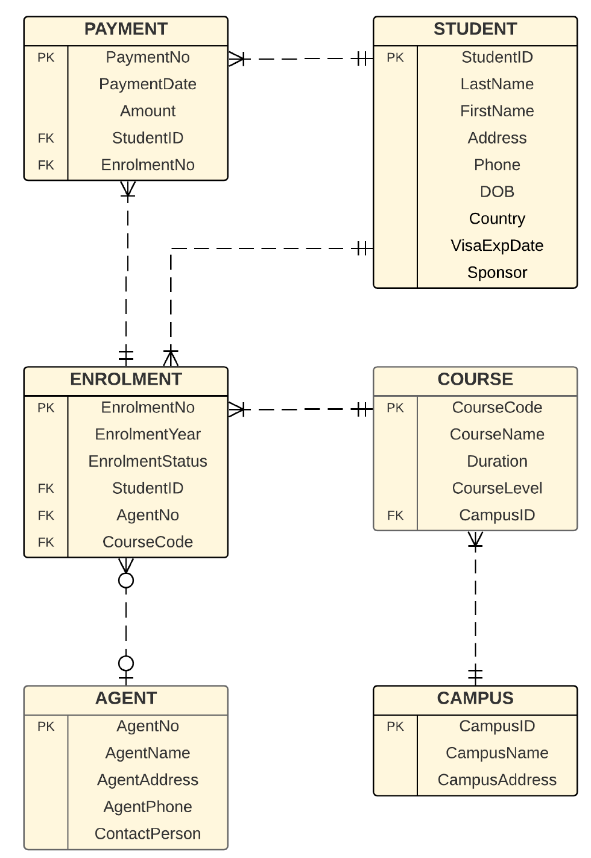

A star schema was created according to the requirements given by the managers:
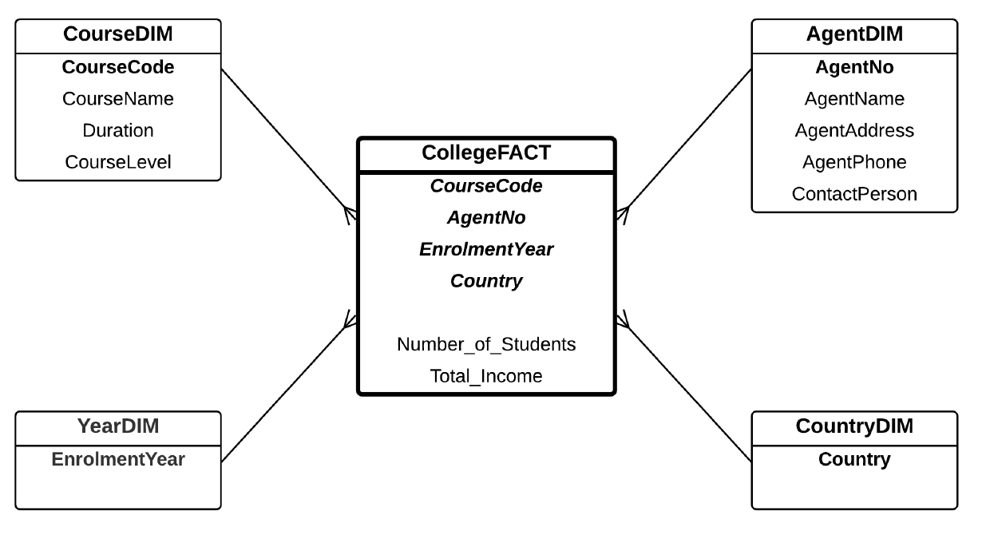
Note that the Year and Country Dimensions are one-attribute dimensions.
Question:
Design two star schemas to replace the given star schema above. The first star schema is to remove both one-attribute dimensions, and make them dimensionless keys in the fact. The second star schema is to replace the two one-attribute dimensions with a junk dimension.
Solution:
College Star Schema with Enrolment Year and Country as Dimension-less Keys:
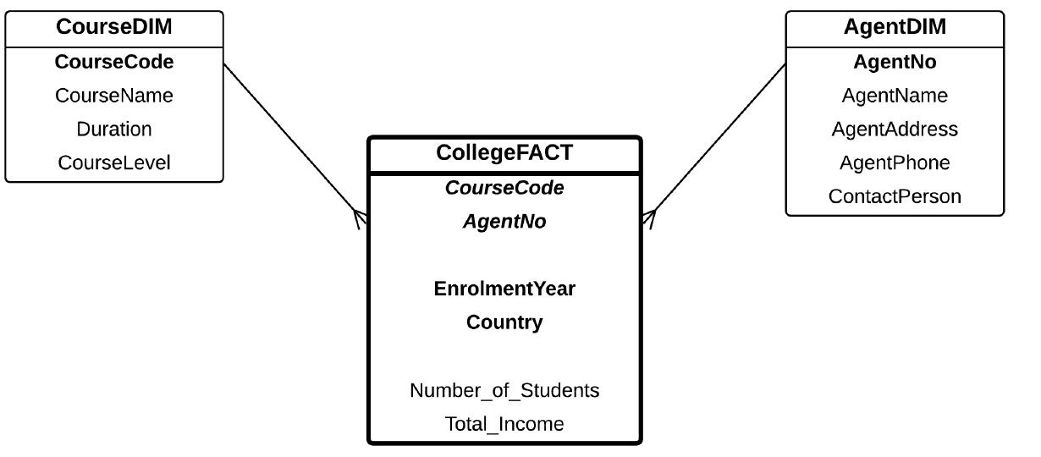

College Star Schema with Junk Dimension
